**ES Lab 2 Report**

**Programs on Data Transfer Instructions**

Date: 15th January, 2025

Phirozgar Irani

230905370

CSE 4B: B2

Q1. WRITE AN ARM ASSEMBLY LANGUAGE PROGRAM TO STORE DATA INTO GENERAL PURPOSE REGISTERS

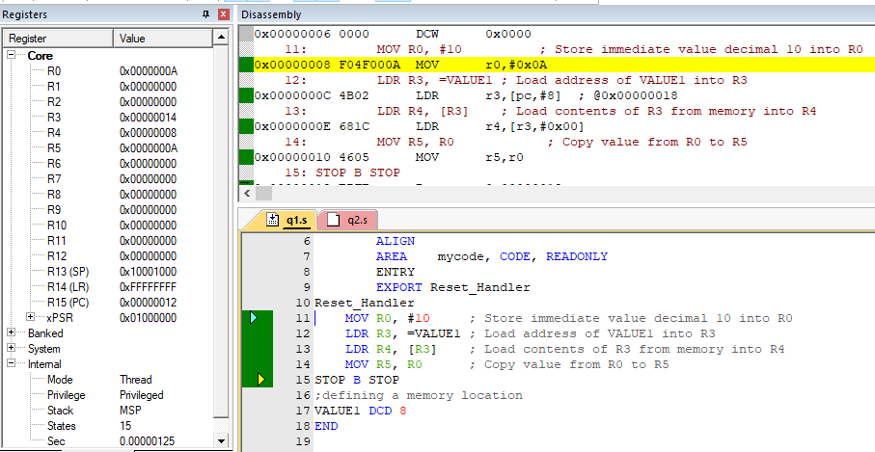

Q2. WRITE AN ARM ASSEMBLY LANGUAGE PROGRAM TO transfer a 32-bit number from one location in the data memory to another location in the data memory.

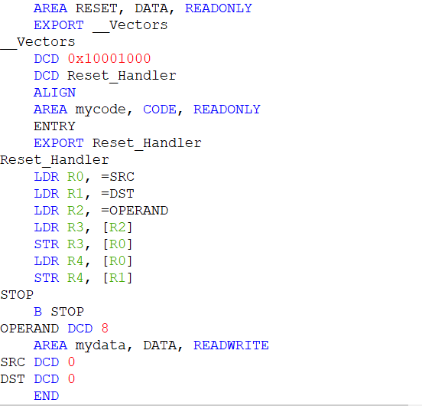

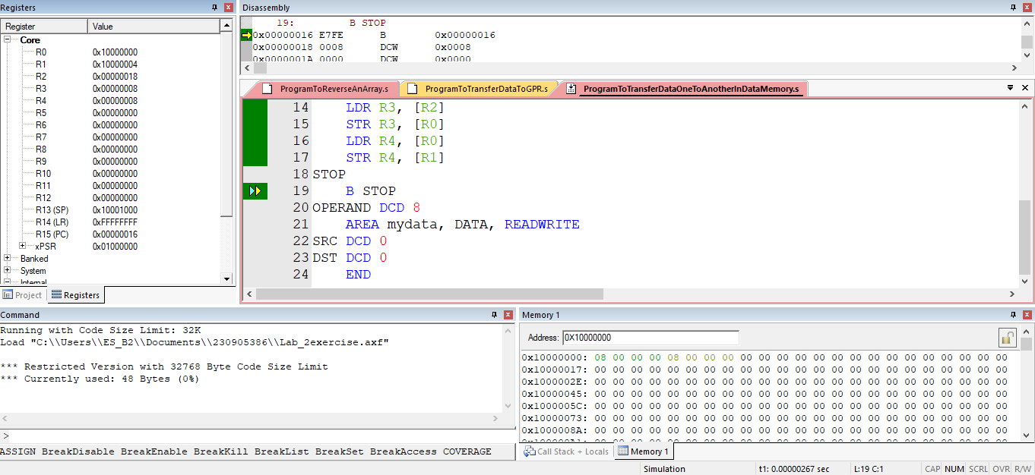

Q3. WRITE AN ARM ASSEMBLY LANGUAGE PROGRAM TO transfer block of ten 32-bit numbers from code memory to data memory when the source and destination blocks are non-overlapping.

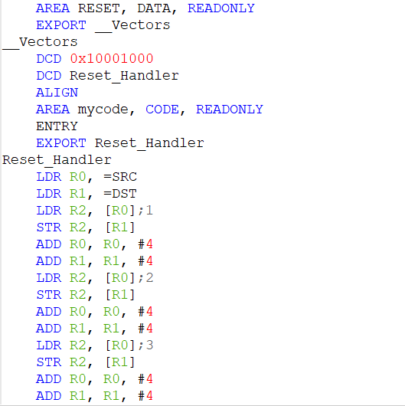

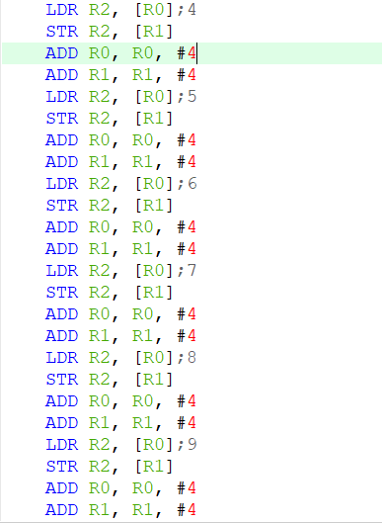]

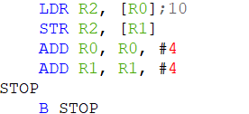

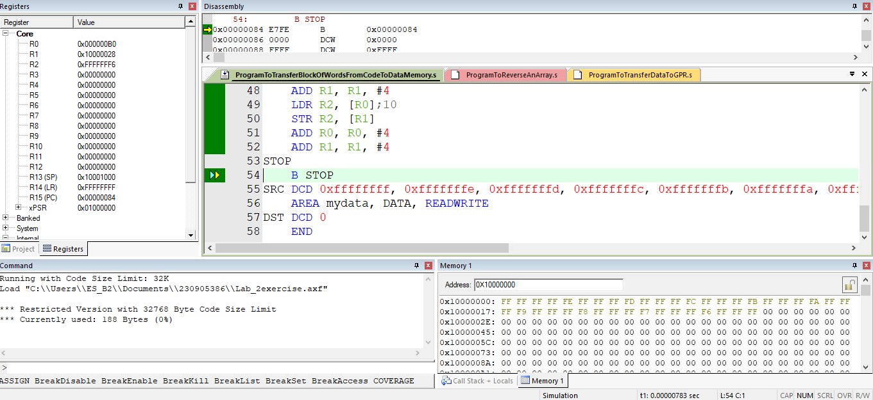

Q4. WRITE AN ARM ASSEMBLY LANGUAGE PROGRAM TO Reverse an array of ten 32-bit numbers in the memory.

